UNIVERSITY INSTITUTE OF COMPUTING

PROJECT REPORT
ON
Cricket Player Performance Analysis using R

Subject Name – R PROGRAMMING LAB
SUBJECT CODE- 25CAP-161
SUBMITED BY:
Team name:RO-KO
Name : Kushager and Sukhbeer UID : 25BCD10039 and 25BCD10043

Branch : UIC Group: B

Section:25BCD-1 Semester :2nd

SUBMITED TO:

Name : Miss.Sushma

Desigination:Assistant Professor
Sign:___________________

INTRODUCTION
Cricket is one of the most popular sports in the world, followed by millions of fans across different countries. Performance analysis in cricket plays a significant role in evaluating players and improving team strategies. With the advancement of data analytics, it has become possible to analyze player performance using statistical tools and programming languages.
This project focuses on analyzing cricket player performance using the R programming language. The dataset used in this project contains key attributes such as matches played, runs scored, balls faced, and strike rate. These parameters are essential for understanding a player’s performance and consistency.
The main purpose of this project is to demonstrate how data analysis techniques can be applied to real-world sports data. By using visualization tools such as bar charts, histograms, and scatter plots, patterns and relationships in the data can be easily identified. This helps in comparing players and identifying top performers based on their statistics.
Furthermore, this project highlights the importance of data-driven decision-making in sports analytics. Coaches, analysts, and selectors can use such analysis to make informed decisions regarding team selection and player performance.

Objectives:
The primary objectives of this project are as follows:
- To analyze cricket player performance using R programming
- To compare players based on runs scored
- To study the distribution of strike rate among players
- To identify the relationship between matches played and runs scored
- To visualize data using different types of graphs
- To identify top-performing players based on statistical analysis

Data Description:
The dataset used in this project contains performance-related information of cricket players. It is stored in CSV (Comma Separated Values) format, which is widely used for data storage and exchange.
The dataset includes the following attributes:
- PlayerName: Represents the name of the player
- Matches: Indicates the total number of matches played
- Runs: Represents the total runs scored by the player
- Balls: Indicates the number of balls faced
- StrikeRate: Represents the strike rate of the player
This dataset is simple and suitable for performing basic data analysis. It provides sufficient information to understand player performance and analyze relationships between different variables.

Tools and Technologies
The following tools and technologies are used in this project:
- R Programming Language:
R is used for data analysis, statistical computation, and graphical representation. It is widely used in data science and analytics.
- dplyr Package:
This package is used for data manipulation and transformation. It helps in filtering, grouping, and summarizing data efficiently.
- ggplot2 Package:
This package is used for advanced data visualization. It provides better and more professional graphical outputs.
- CSV File:
The dataset is stored in CSV format, which is easy to read and process in R.
R provides a powerful environment for statistical computing and visualization, making it ideal for this project.

CODE:
# load libraries
library(dplyr)
library(ggplot2)

# load data
data <- read.csv("cricket.csv")
View(data)

# runs comparison
barplot(data$Runs,
names.arg=data$PlayerName,
main="Runs Comparison",
xlab="Players",
ylab="Runs")

# strike rate histogram
hist(data$StrikeRate,
main="Strike Rate Distribution",
xlab="Strike Rate")

# matches vs runs
plot(data$Matches, data$Runs,
main="Matches vs Runs",
xlab="Matches",
ylab="Runs",
col = data$Matches + data$Runs,
pch = 16)

# ggplot bar graph
ggplot(data, aes(x=PlayerName, y=Runs)) +
geom_bar(stat="identity") +
ggtitle("Runs by Player")

# balls vs runs
ggplot(data, aes(x = Balls, y = Runs, color = Runs)) +
geom_point() +
ggtitle("Balls vs Runs")

# mean runs
mean_runs <- mean(data$Runs)
print(mean_runs)

# correlation
correlation <- cor(data$Matches, data$Runs)
print(correlation)

# top player
top_player <- data$PlayerName[which.max(data$Runs)]
print(top_player)

# average strike rate
avg_sr <- mean(data$StrikeRate)
print(avg_sr)

# sort players by runs
sorted_data <- data[order(-data$Runs), ]
print(sorted_data)

4.1 Code Explanation:

The project begins with loading the required libraries such as dplyr and ggplot2. These libraries are essential for data manipulation and visualization.
The dataset is then imported into R using the read.csv() function. This function reads the CSV file and stores it in a data frame for further analysis.
After loading the data, different types of graphs are created:
- Bar Plot:
Used to compare runs scored by different players. It helps in identifying the highest and lowest scoring players.
- Histogram:
Used to display the distribution of strike rates. It shows how the values are spread across different ranges.
- Scatter Plot:
Used to analyze the relationship between matches played and runs scored. It helps in identifying trends and patterns.
In addition to visualization, statistical functions are also used:
- Mean:
Used to calculate the average runs and strike rate.
- Correlation:
Used to measure the relationship between matches and runs.
The which.max() function is used to identify the player with the highest runs, while sorting techniques are used to rank players based on performance.

OUTPUT:
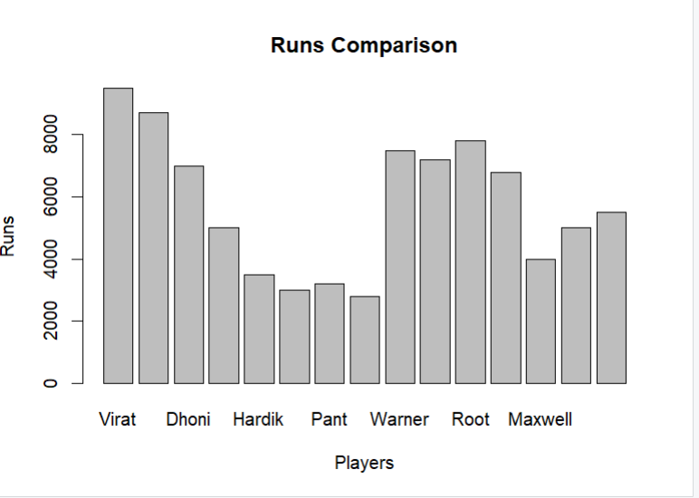
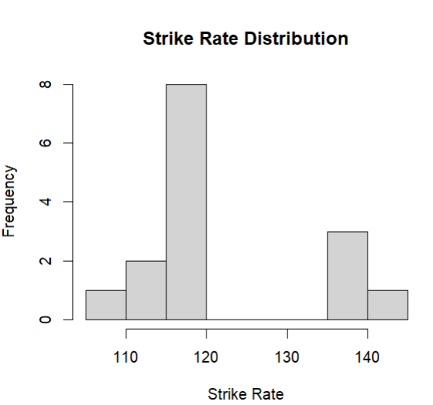
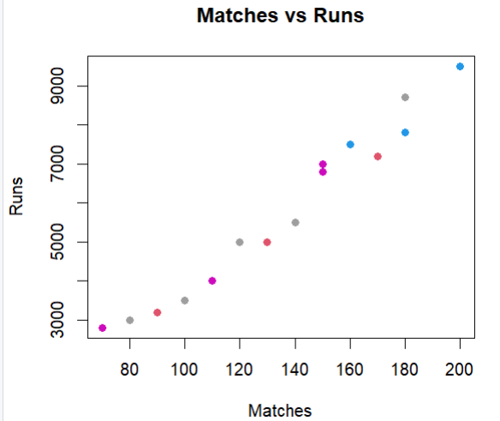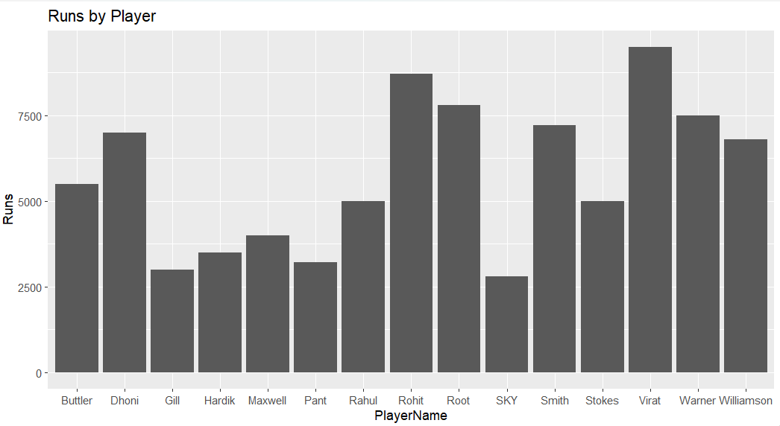
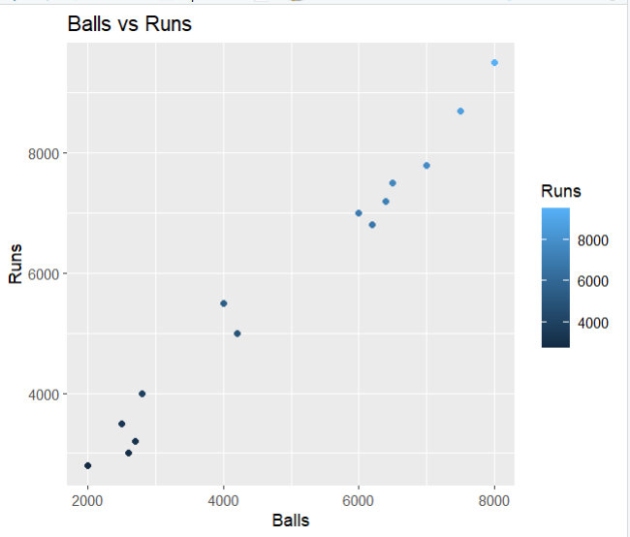
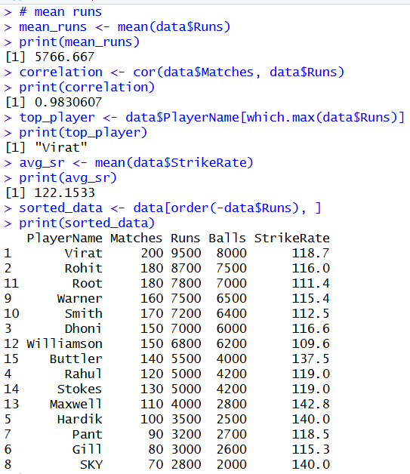

Conclusion:
This project successfully demonstrates how R programming can be used for analyzing cricket player performance. By applying basic statistical techniques and visualization methods, it becomes easier to compare players and identify performance trends.
The use of graphical representations such as bar charts, histograms, and scatter plots makes the data more understandable. Statistical measures such as mean and correlation provide deeper insights into the dataset.
Overall, this project highlights the importance of data analysis in sports and how it can be used to make informed decisions.
.

--------------------------------------------------------------------------------- Learning Outcomes:
The following learning outcomes were achieved through this project:
- Understanding of data import using CSV files
- Knowledge of data visualization techniques
- Understanding of basic statistical concepts such as mean and correlation
- Ability to analyze real-world datasets
- Improved proficiency in R programming

Future Scope:
This project can be further enhanced in several ways to make the analysis more comprehensive and advanced:
- Adding more player statistics such as batting average, centuries, half-centuries, and strike rate in different match formats
- Using larger and real-time datasets to improve accuracy and reliability of analysis
- Applying advanced statistical and analytical methods for deeper insights
- Creating interactive dashboards for better visualization and user interaction
- Performing predictive analysis to forecast player performance
In addition to the above, the project can also be improved by:
- Including data from different formats of cricket such as Test, ODI, and T20 to compare performance across formats
- Analyzing player performance over time to study consistency and improvement trends
- Comparing players from different teams or countries for better evaluation
- Integrating data from external sources such as APIs or sports databases
- Using data cleaning techniques to handle missing or inconsistent values
Furthermore, the project can be extended by:
- Developing a ranking system based on multiple performance parameters
- Visualizing advanced metrics using more detailed graphs and charts
- Automating data updates for continuous analysis
- Creating a user-friendly interface for easy access to insights
Overall, these enhancements can make the project more powerful, practical, and suitable for real-world sports analytics applications.

Github link

https://github.com/kushager45/Cricket-Player-Performance-Analysis-using-R

Screenshot:

